Model used: Gradient Boosting was used to see if accuracy of previous model could be improved

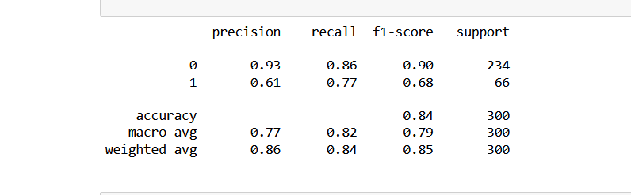

84 % accuracy achieved. Model needs hyperparameter tuning